**1) Create one VPC,with 1 one public subnet and 1 private subnet**

Subnets

Public 1

Private 1

**2) Enable VPC peering for cross region.**

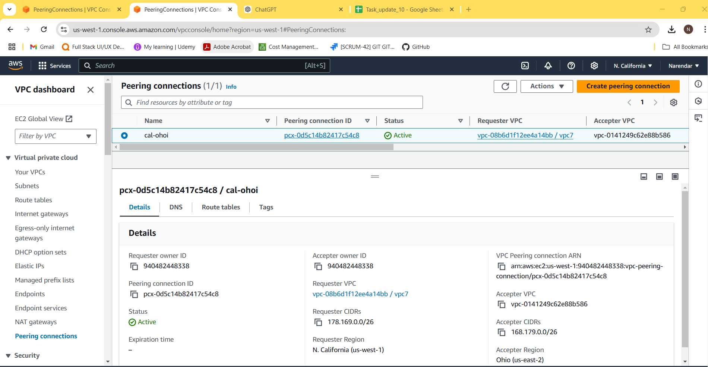

**3) Enable VPC peering for cross account. (You can collaborate with your friend and do this task).**

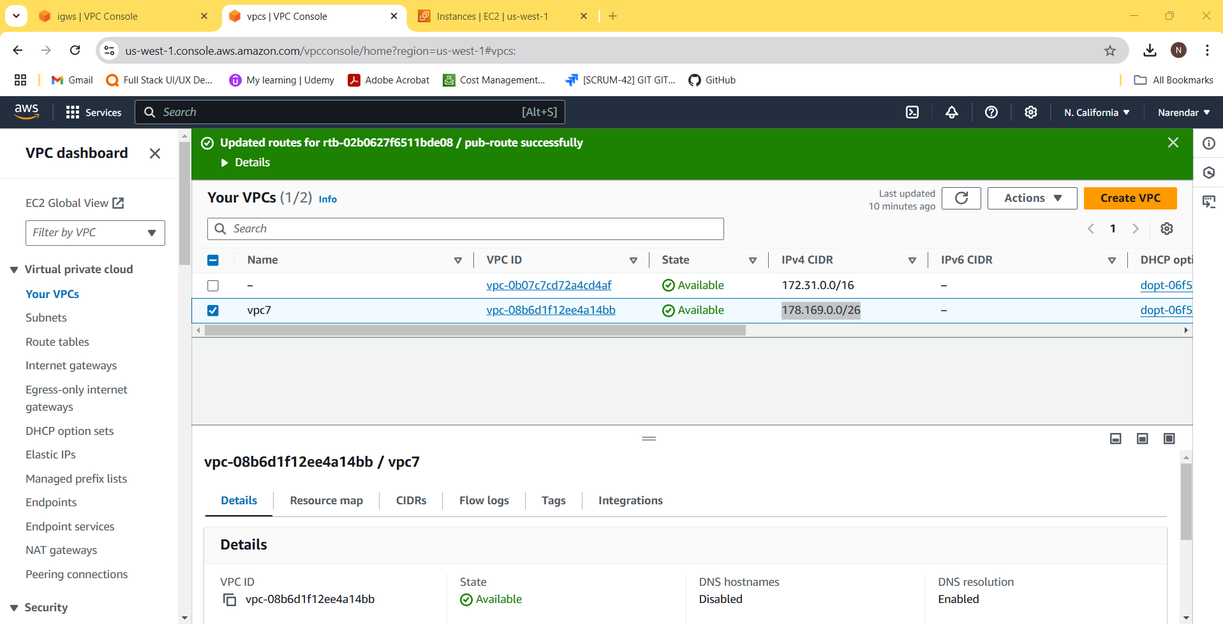

**4) Setup VPC Transist gateway**

**5) Setup VPC End Point**

